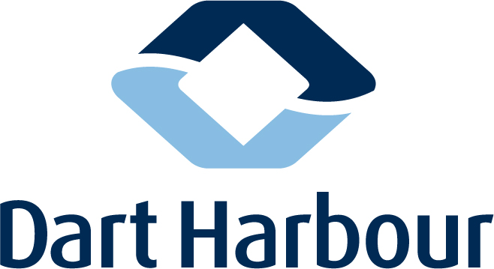

MARITIME EVENT REQUEST FORM

Before the start of any group activities or events on the River Dart, Dart Harbour must be notified in writing (letter or e-mail) of the event. Please complete this Maritime Event Request Form and a Risk Assessment Form at least one month before the event and send to info@dartharbour.org or to 6 Oxford Street, Dartmouth, TQ6 9AL. If you would like to discuss your event, please contact us on 01803 832337.

Failure to register in advance and provide sufficient time for Dart Harbour to review safety documentation and issue any appropriate navigation warnings may result in events not being approved.

Event Name:

Organisation name:

Contact name, address, telephone and email:

Please fill in all boxes as appropriate.

Timetable and programme of events:
Date | Time | Event
Number of anticipated participants:

Authorities consulted: (Governing bodies etc whose guidelines your event conforms to. Other bodies who provide advice etc.)

Arrangements for controlling the event: (Include number & type of safety craft, safety personnel, VHF Channel, Mobile Telephone Number and other controlling factors.)

Navigational constraints proposed: (Any issues involving tides, shipping etc that might affect the event.)

Emergency Plan: (Attach an emergency action plan or briefly overview your plans to deal with a more serious incident involving Ambulance on site, Police, Fire Service, Coast Guard, RNLI etc.)

Media arrangements: (Any planned involvement of media, TV, Radio, Newspaper)

Assistance/support requirements from Dart Harbour: (Please detail any support you anticipate requiring e.g. monitoring of other river traffic, deconfliction with other events, website notices etc.)

Insurance cover: (Provide a summary of cover and attach a certificate of insurance for the event activities)

Be signing this form you agree that:-

- You understand that Dart Harbour accepts no responsibility or liability for these activities and that it is the responsibility of event organisers to ensure that they evaluate all risks and take appropriate measures to control any potential hazards;

- A risk assessment has been signed by the responsible person (and is attached) and addresses the appropriate risks with suitable mitigations. (Guidance is available if required).

- You will be accepting responsibility for the events detailed above and if there are any changes to be made, you will contact Dart Harbour prior to the start of the activity.

To be signed by the person responsible for the event.

Signed .................................................................. Date:.......................................

Print:.......................................................................

On behalf of (Organisation Name) :...........................................................................................................

Office Use (Dart Harbour)

Form Completed
Risk Assessment enclosed
Site Specific Risk Assessment enclosed
Assistance from Dart Harbour
Added to Event Log

