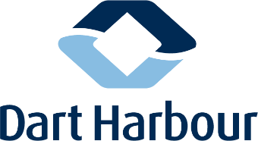
NORTH EMBANKMENT ACCESS IMPROVEMENTS

– STAKEHOLDER FEEDBACK FORM

Complete sections as applicable
Name: |  | Mooring Type
Organisation/Club:

Do you support the strategy to improve access to the water at the North Embankment? |  |  | Y/N
Comment:

Tell us about your experience of using the Double Steps pontoon:

What improvements, if any, would you like to see?

What attributes of the existing facility would you like to see retained?

What concerns you about the potential for reconfiguring access and facilities in this area?

Does the preliminary project brief adequately summarise the opportunity?

“The development of concept proposals for the modification and improvement of the Double Steps Pontoon at Dartmouth.
With full consideration to the project drivers, constraints and opportunities described herein, concept proposals should seek to address the following as a minimum:
  - Improve public access to the pontoon addressing health and safety concerns
  - Improve access to the water for a range of river users and stakeholders
  - The introduction of a deep-water landing for 12 men craft and the Noss to Dartmouth Ferry”

Y/N | Comment:
Please provide your feedback to the Harbour Office by 29th February 2020.
Email to: info@dartharbour.org

